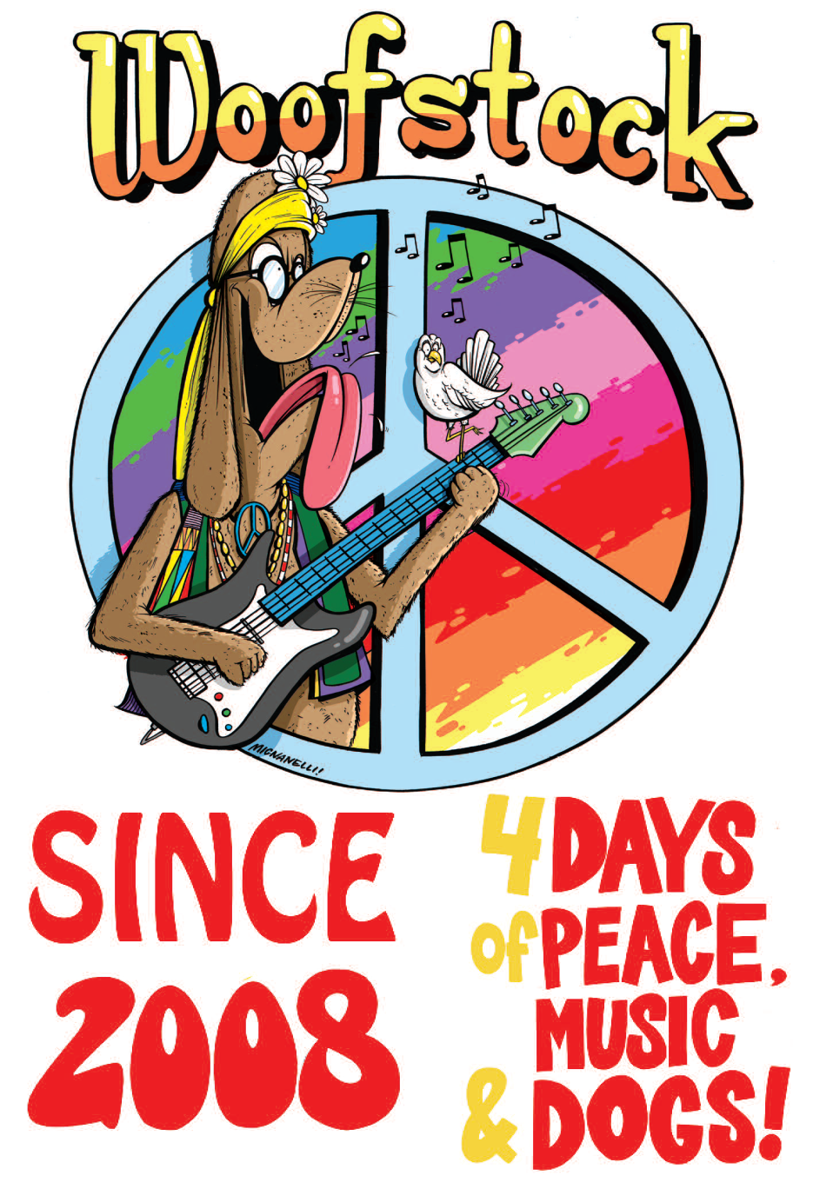
WOOFSTOCK CLUSTER 2019

June 6-9, 2019

Hosted by
Yosemite Kennel Club
Contra Costa County Kennel Club

“Exhibitor Friendly Shows”
Enjoy music all day long!

The Woofstock Cluster dog clubs cordially invite you to be a part of our combined all breed dog shows and
specialties. Please return the enclosed form along with your check and a copy of your California resale certificate by May 1st. Your resale certificate will be verified with the California State Board of Equalization.

Vendor space is limited and by invitation only. No reservations will be made without payment in full. If you have downloaded this form from the website, space availability is not guaranteed. Please contact vendor chair to verify availability. The shows will be advertised and open to the public. We average 2600 entries per day. Booth space is assigned at the discretion of Vendor Chair and is based solely on the arrival of your check by the above date. The club does not furnish shade, covers, chairs or tables. These items will be your responsibility. Please advise us if you will not be able to have your booth open all four days.

***Please note: No vendors are allowed to sell tie dye T shirts or sweatshirts. Anyone selling them will be asked to remove them.

***VENDOR DECORATION CONTEST FOR BEST DECORATED BOOTH ON “TIE DYE SATURDAY!”
Judging begins at 10:00 am on Saturday. Prize is the value of a 10 x 10 both space ($275 value)
GOOD LUCK TO ALL!

The Solano County Fire Department enforces fire safety regulations at the Solano County Fairgrounds. They have imposed the following requirements for tents and canopies used by the Woofstock Cluster, its vendors and exhibitors.
PLEASE NOTE THE FOLLOWING DEFINITIONS AND REGULATIONS. We will need to know the size and type of either tent or canopy you intend to use.

TENTS: Tents are defined as “temporary structure, enclosed or shelter constructed of fabric or pliable material supported by any manner except air of the contents it protects”. (Has sidewalls or drops on over 25% of perimeter)

CANOPIES: Canopies are defined as “temporary structure, enclosure or shelter constructed of fabric or pliable material supported by any manner except air or the contents it protects without sidewalls or drops on 75% or more of the perimeter.”

A Fire department permit is required to erect tents 200 square feet or over or any canopy 400 square feet or over. As we have to apply for the permits, we will need to know the size and type of structure you intend to use. If your shelter falls into the above categories requiring a permit, you will need to provide a fire extinguisher with a minimum rating of
2A-10BC.

All tent, canopy and interior decorative fabric is required to be flame department in accordance with State Fire Marshall standards (Uniform Fire Code 3205). Smoking is prohibited in all tents and canopies! We thank you in advance for your understanding.

Approximately two weeks prior to the shows you will receive a map of the fairgrounds with your booth space number and location.

Set up times: Wednesday June 5th 10:30 am to 8:00 pm Vendor booths: Thursday-Sunday 7:15 am to 6 pm

We ask that you unload and remove your vehicles as quickly as possible to minimize interference with other show set up activities. All vehicles MUST be off the show grounds by 7:15 am. We will be on the show grounds to assist you on
Wednesday from 10:30 am and Thursday through Sunday 7:15 am to 6:00 pm. Absolutely NO space swapping, changes
or subletting of spaces is allowed.

Access to the fairgrounds for take down and loading out will not be available until after the groups are finished on Sunday. THIS WILL BE STRICTLY ENFORCED. Before leaving on Sunday we ask that you remove all boxes and trash from your areas and place them in the dumpsters provided.

Again, please note that your completed form, check and copy of your resale permit must be returned by May 1st.
Failure to submit the above items by this date may result in not being able to participate. Thank you in advance for your cooperation.

We do try to ensure a successful four days for all and look forward to having you as part of our shows. If you have any further questions, please do not hesitate to give the vendor chair a call.

Thank you very much,

Contra Costa County KC and Yosemite KC

DAVE AND DIANE BOONE – CONCESSIONS CHAIRPERSON(S)
2280 Grass Valley Hwy #159, Auburn, CA 95603
Cell 408-858-5763
dwboone@dslextreme.com

